JEE Main 2026 Chapter-Wise Weightage- Important chapters in Physics, Chemistry and Moths


Search your topic here...

* Start Your JEE Practice Here : JEE Test series 2026

Which Chapters Hove the Highest Weightage in JEE Main 2026 for Physics, Chemistry and Moths?

Preparing for JEE Main 2026 becomes easier when you know which chapters carry the highest marks in Physics, Chemistry, and Mathematics. The JEE Main chapter- wise weightoge helps students focus on important topics that ore frequently asked in the exam.

Candidates con check here the high-welghtage chapters for all three subjects along with the JEE Main 2026 weightoge PDF and previous 5-year analysis to plan their preparation smartly.

Since the official weightoge distribution is not revised every year, students should rely Dn previous—year trends to identify the mDst important topics thot cDnsistently appear in the exam.

JEE Main Post 5 Years Chapter-Wise Weightage (2021-2025)

Understanding the
post five years' JEE Main chapter-wise weightoge helps students recognise recurring high—weightage topics and focus their preparation mDre strategically. Below you‘ll find a detailed analysis for Mathematics, Physics, and Chemistry, based on question distribution and chapter weightoge trends Dbserved between 2021 and 2025.

JEE Main Post 5 Years Chapter-Wise Weightage for Mathematics
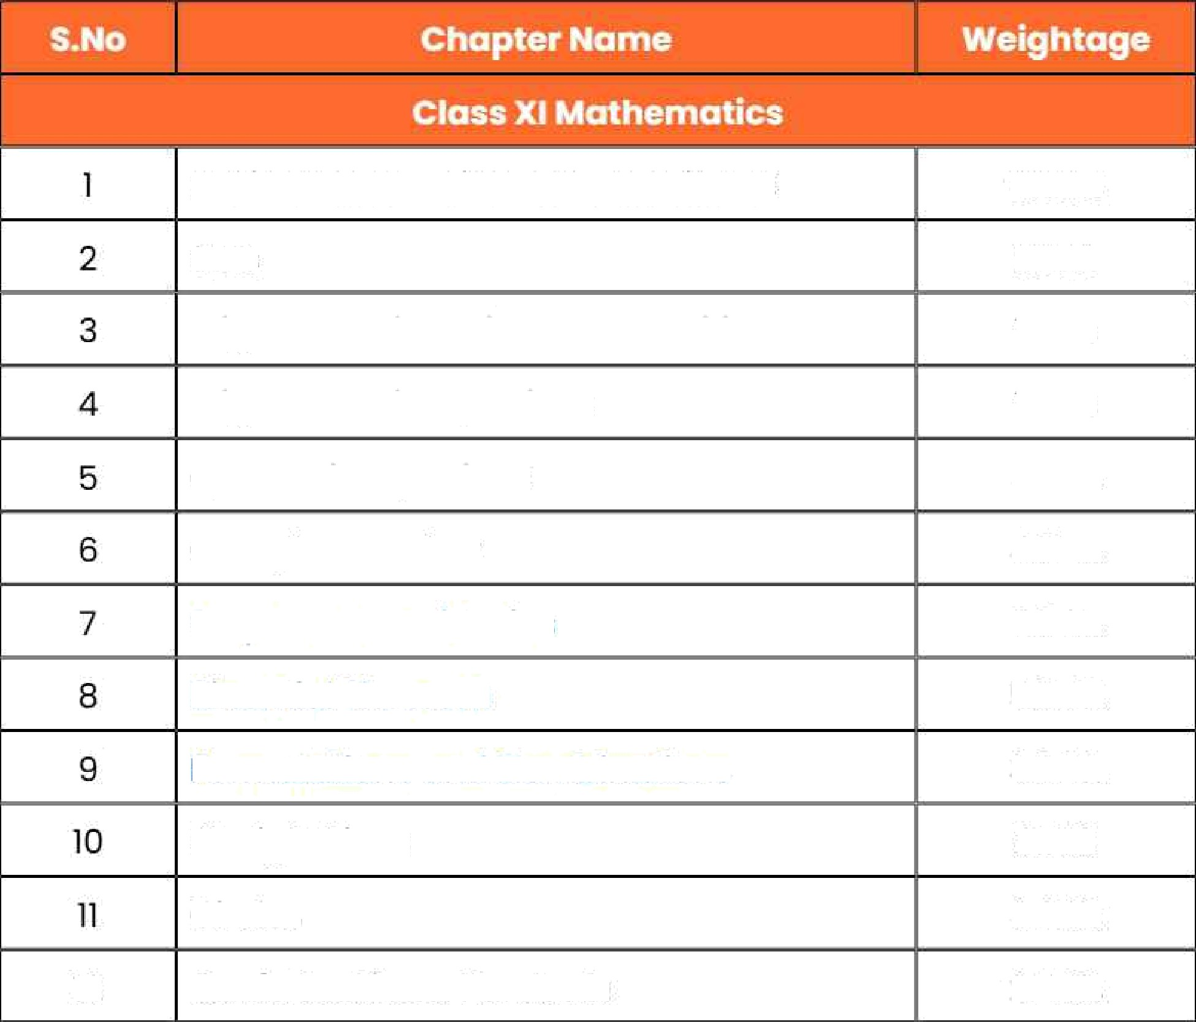
The Mathematics section in JEE Main focuses heavily on Algebra and Calculus, which tDgether account far nearly 70% of the paper. Reviewing chapter—wise weightoge from the post five years helps candidates identify the most scoring topics.

 | Basic Mathematics and Logarithms | 0.59%
 | Sets | 1.00%
 | TrigDnometriC Ratios and Identities | 1.02%
 | TrigDnometric Equations | 135°f,
 | Quadratic Equations | 3.30%
 | Complex Number | 4.75%
 | Sequences and Series | 5.74%
 | Binomial Theorem | 5.05%
 | Permutations ono Combinations | 360%
 | Straight Lines | 2.71%
12 | Circles  Conic Sections: Porobolo | 124%  Z44%

.'E

13 | Conic Sections: Eliipse | 2.11%
14 | Conic Sections: Hyperbole | 1.65%
15 | Statistics | 3.OO%
16   | Properties of a Triangle | 0.36%
l | Determinants | 4.00%
2 | Matrices | 3.46%
 | RelotiDns and Functions | 1.25%
4 | Inverse Trigonornetric Functions | 1.59%
 | imit, Continuity and Differentiobility | 5.50%
 | MethDctS Of Differentiation | 1.24%
7 | Applications of Derivatives | 4.75%
 | Indefinite Integration | 1.65%
 | Definite Integration | 5.o8%
1o | Application of Integrols | 2.97%
11 | Differential Equations | 4.16%
12 | Vector Algebra | 4.6g%
13 | Three- Dimensional Geometry | 7.35%
14 | Probability | 3.09%

Trend Insight:
Over the post five years, 3D Geometry, Sequences and Series, Calculus, and Binomial Theorem have consistently carried significant weightoge. Students should focus more on these chapters while ensuring conceptual clarity in Algebra and Coorctinate Geometry.

JEE Main Post 5 Years Chapter-Wise Weightage for Physics
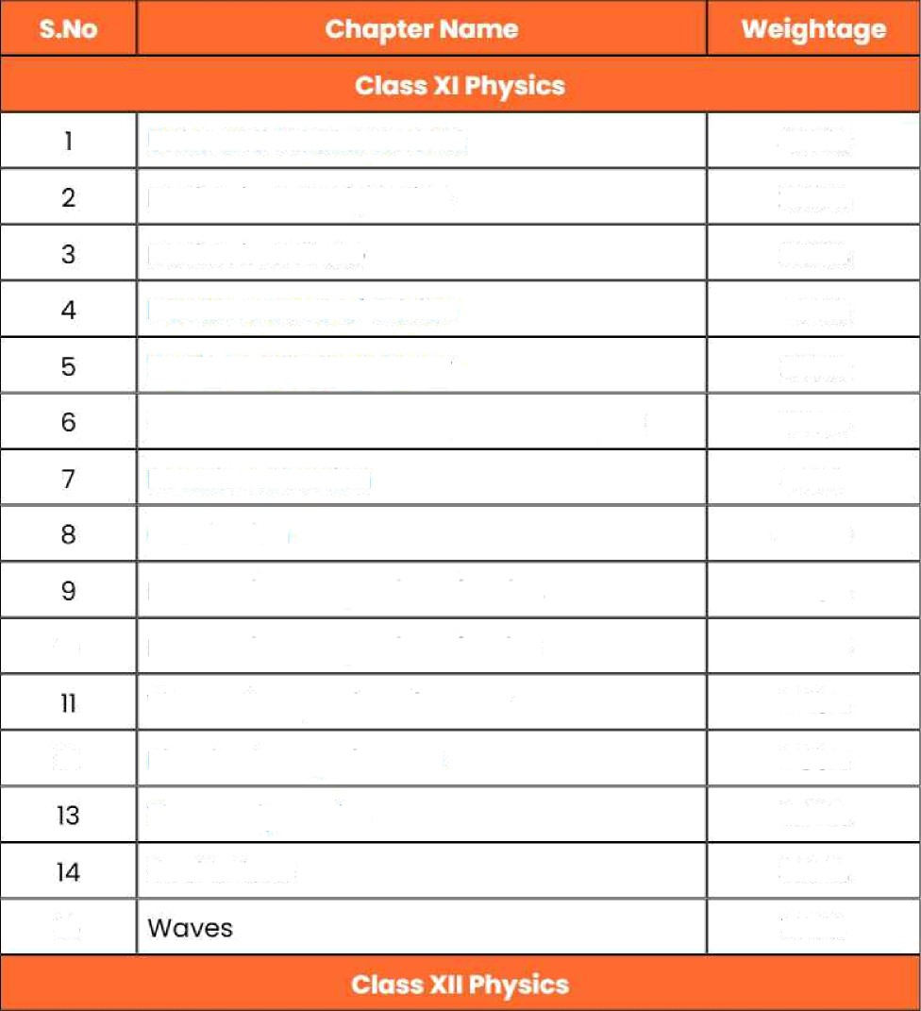
The Physics section tests conceptual clarity and numerical problem—solving. The analysis of the post five years shows that Mechanics, Electrostotics, and Modern Physics dominate the paper, accounting for over 70% of questions.

 | Units and Measurements | 4.240/.
 | Motion in a Straight Line | 2.63%
 | Motion in a Plane | 2.92%
 | Newton's Laws of Motion | 2.05%
 | Work, Energy and Power | 2.37%
 | Centre of Moss and System of Particles | 2.56%
 | Rotational Motion | 4.31%
 | Gravitation | 4.49%
 | Mechanical Properties of SD1Ids | 2.08%
10 | Mechanical Properties of Fluids | 
 | Thermal Properties of Matter | 2.08%
12 | Kinetic Theory of Gases | 2.88%
 | Thermodynamics | 8.06%
 | Oscillations | 3.25%
15 |  | 1.94%

i | Electric Charges and Fields | 3.18%
2 | Electrostatic Potential and Capacitance | 4.49%
a | Current Electricity | 6.57%
4 | Moving Charges and Magnetism | 2.8g%
s | Magnetism and Matter | 1.90%
6 | Electromagnetic Induction | 3.25%
7 | Alternating Current | 3.73%
8 | Electromagnetic Waves | 2.96°f.
9 | Ray Optics and Optical instruments | 5.04%
10 | Wo've Optics | 2.30%
11 | Dual Nature of Radiation and Matter | 4.05%
12 | Atoms | 2.48%
13 | Nuclei | 3.14%
14 | Semiconductor Electronics | 4.75%

Trend Insight:
Electrostotics, Roy Optics, Current Electricity, Thermodynamics, and Rotational Motion are among the top-weightage tDpics. Prioritising these, along with Modern Physics and Mechanics, con help students secure strong marks in the Physics section.

JEE Main Post 5 Years Chapter-Wise Weightage for Chemistry

Chemistry offersa balance of conceptual and memory—based questions. Based on post trends, Physical and Organic Chemistry contribute the most, though key chapters from Inorganic Chemistry continue to repeat every year.

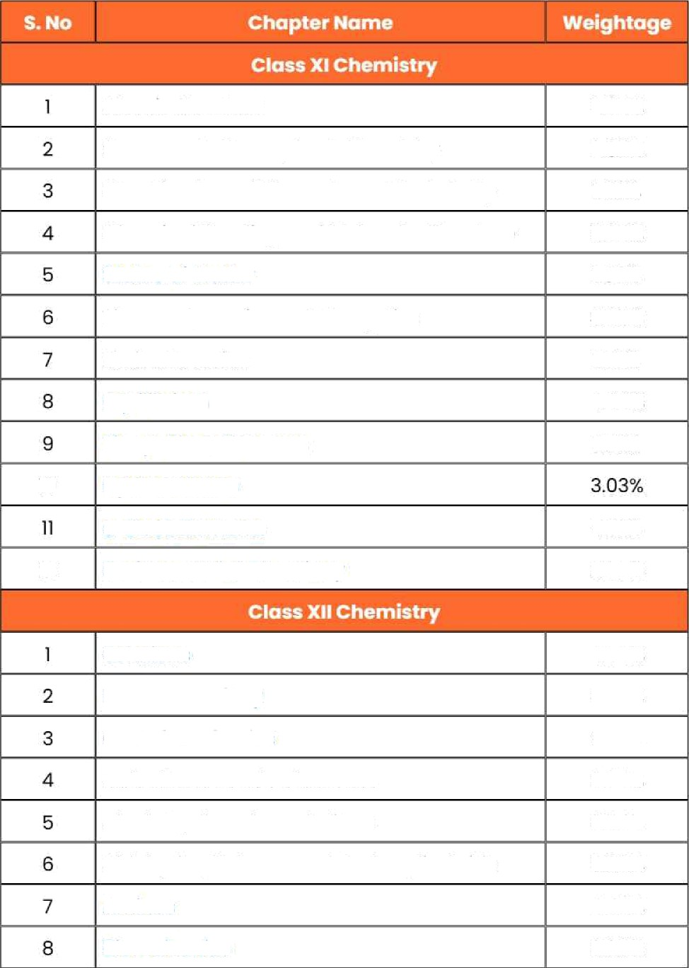

 | Atomic Structure  Some Basic Concepts of Chemistry ClossificotiDn of EJements and Periodicity | 3.34%  2.82°f  1.93%
 | Chemical Bonding and Molecular Structure | 3.34%
 | States of Matter | 1.89%
 | Thermodynamics and Energetics | 3.65%
 | RedDx Reaction | 1.75%
 | EqLiilibrium | 4.44%
 | The p- BIoCk Elements | 1.79%
JO | Hydrocarbons
 | s-Block Elements | 4.16%
12 | Environmental Chemistry | 2.99%
 | Solutions | 454%
 | Electrochemistry | 330%
 | Chemical Kinetics | 3.61%
 | Holaolkones and Holoorenes | 2.65%
 | AICDhoIs, Phenols and Ethers | 354%
 | Aldehydes, Ketones and CorbDxylic Acids | 5.95%
 | Amines | 4.40%
 | Biomolecules | 3.99%

9 | Coordination Compounds | 5.33%
10 | p-Block Elements (Group 15-18) | 3.68%
11 | d- and f- Block Elements | 4.69%
12 | Polymers | 2.06%
13 | Chemistry in Everyday Life | 2.20°f

Trend Insight:
Chapters like Aldehydes, Ketones and Corboxylic Acids, Coordination Compounds, Electrochemistry, and Equilibrium appear regularly. Focusing on these, along with Thermodynamics and Chemical Bonding, ensures a balanced Chemistry score.

Topic-Wise Questions Distribution in JEE Main 2025
JEE Main 2025 was cDnductecl in two sessions (January and April). The tables below show how many questions were asked from each chapter across Physics, Chemistry, and Mathematics.

JEE Main Mathematics - Chapter-wise Questions
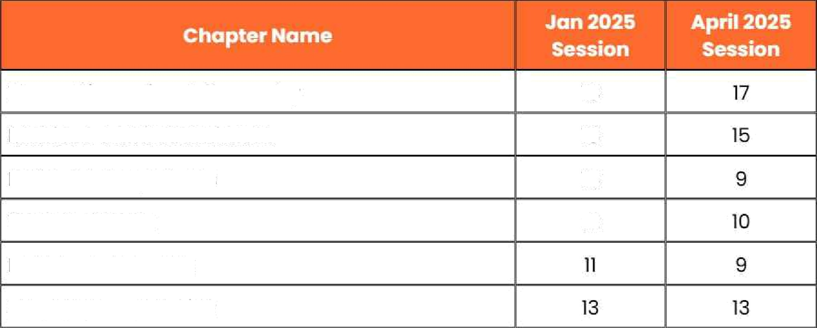
Three-Dimensional Geometry Matrices and Determinants Differential Equations
Vector Algebra
is
ia is
12
Definite Integration
Sequence and Series

Straight Lines | 11 | 9
Binamiol Theorem | 11 | 1a
Set TheDry ond Relations | 11 | 9
Application of Derivatives | 4 | 9
Functions | 10 | 11
PrDbability | 12 | 9
Limits of Functions | 10 | 9
Permutations ond Combinations | lz | 9
Circle | 5 | 4
Differentiobility ond Method of Differentiotion | 2 | 2
Quodratic Equotions | 8 | 8
Complex Numbers | 8 | 8
Stotistics | 4 | s
Hyperbola | s | 7
CDntlnuity | 2 | 2
Trigonornetric Equotlons | 2 | s
Parabole | 10 | 6
Indefinite Integration | 5 | 3
Inverse Trigonometric FunctiDns | 7 | 4
Ellipse | 7 | 9
Trigonometric Ratios and Iclentities | z | 2
SDlUtionS of Triangles | 0 | 0
Basic Mathematics ond Logarithms | 1 | 0

JEE Main Chemistry - Chopter-wise Questions

Orgonic Chemistry - SDme Basic Principles ond Techniques |  |  | 2O
CoDrdination Campounds |  | 18 | 22
Aldehydes, Ketones ond Corboxylic | Acids | 1s | 18
Thermodynomics |  | 15 | 1s
Equilibrium |  | 17 | 10
SDlUtions  Chemical Kinetics |  | 12 | 16
The d ond f—Block Elements |  | 15
Electrochemistry  SDme Basic Concepts of Chemistry |  | 14
BÎOfTiDlecules
Holoolkones ond Holoorenes |  | 14
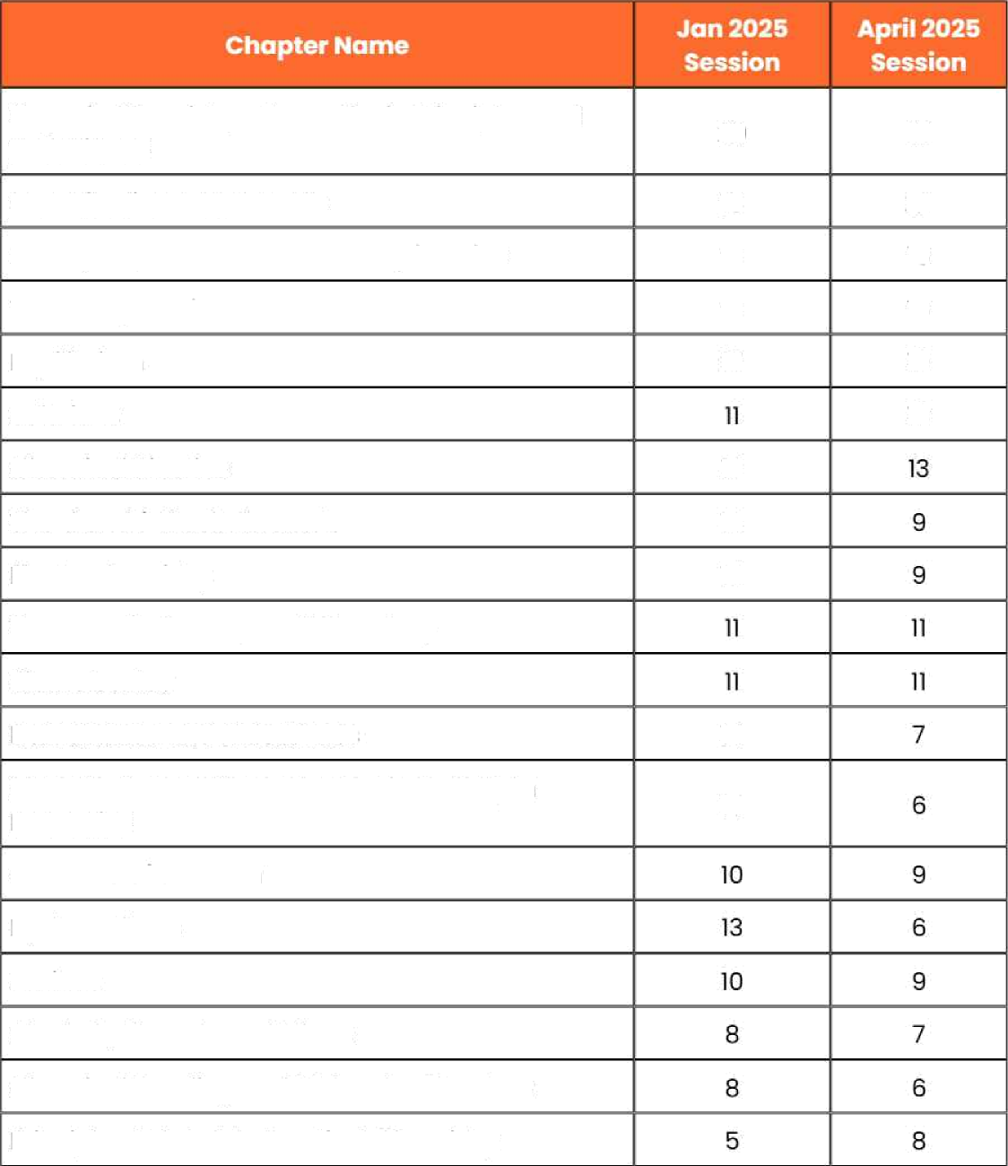
Classification of Elements ond Periodicity in
PrDperties 14
Structure Df on Atom Hydrocorbons Amines
Alcohols, Phenols ond Ethers
Chemical Bonding ond Molecular Structure Principles Reloted tD Practicol Chemistry

The p- Block Elements (Group 15 to 18) | 4 | 6
The p- Block Elements | 2 | 7
Redox Reactions | a | 0

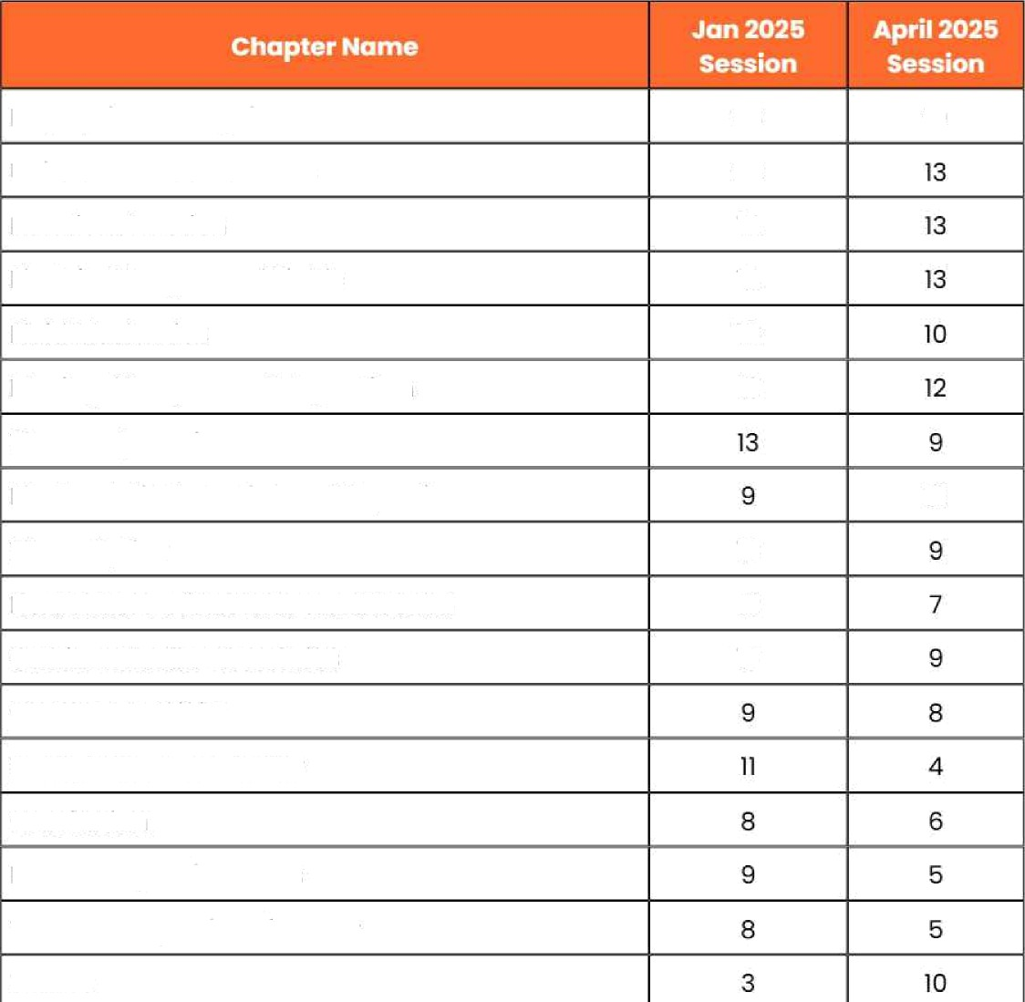
JEE Main Physics- Chapter-wise Questions

Ray Optics and Optical Instruments | 23 | 19
Units and Measurements | 20
Rotational Motion | 14
Electric Charges and Fields | 14
Fluid Mechanics | 16
Moving Charges and Magnetism | 12
Thermodynamics
Electrostatic Potential and Capacitance |  | 12
Wove Optics | 10
Dual Nature of Radiation and Matter | 12
Semiconductor Electronics | 10
Current Electricity
Work, Power and Energy
GrovitotiDn
Electromagnetic Waves
Thermal Properties of Matter
Waves

Alternating Current | 7 | 6
Kinetic TheDry Df Gases |  | 7
Atoms |  | 7
Newton's Laws of Motion | 3 | 8
MDtlon in a Plane | 4 | 6
Motion in a Straight Line | 4 | s
Simple Harmonic Motion |  | 4
System of Particles and Centre of Mass
Nuclei |  | s
Mechanical Properties of SDI)ds | 1 | 6
Electromagnetic Induction |  | i
Magnetism and Matter | 0 | 3
Vector and Calculus | 1 | o

JEE Mains Class-Wise Question Distribution: Mathematics

 |  |  | 
2024 | January | 119 | 181
2024 | April | 115 | 185
2025 | January | 116 | 134
2025 | April | 110 | lls

JEE Mains Class-Wise Question Distribution: Physics

 |  |  | 
2024 | January | 141 | 159
2024 | April | 143 | J57
2025 | January | 121 | 129
2025 | April | 109 | 116

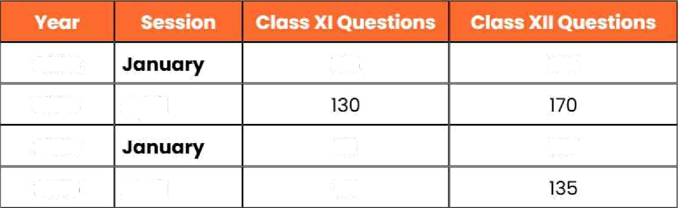
JEE Main Class-Wise Question Distribution: Chemistry

2024 |  | 125 | 175
2024 | April
2025 |  | Ilc | 137
2025 | April | 90

JEE Main Subdiscipline Question Trends: Physics

 |  |  | 
Mechanics |  | 218 (36.3%) | 252 (35.0%)
Electromognetism |  | 186 (31.0%) | 194 (26.9%)
Modern Physics |  | aa (14.7%t | 123 (17.1%}
Heat and ThermodY^•mics |  | 42 (7.0%) | sO (6.g%)
Optics |  | 42 (7.0%) | 63 (8.8%)
oscillation and Waves |  | 24 (4.0%) | 38 (5.3%)

JEE Moin Subdiscipline Question Trends: Chemistry

Organic Chemistry | 228 questions | 169 questions
PhYSiCol Chemistry | 207 questions | 176 questions
Inorganic Chemistry | 165 questions | 130 questiDns

High Weightage Chapters For JEE Mains 202s Focus Areas
- Mathematics: 3D Geometry, Matrices and Determinants, Differential Equations, Binomial TheDrem
- Physics: Roy Optics, ElectrDStotics, Current Electricity, Units and Measurements
- ChemtSt CDOrdinotion Compounds, Aldehydes / Ketones / Carboxylic Acids, ElectrDchemistry, Equilibrium

Focusing on these recurring topics - along with steady practice from previous years' question papers — can significantly increase your chances of scoring well in JEE Main 2026.

The National Testing Agency (NTA) has released the JEE Main 2026 exam pattern, giving students a clear idea of how this year's exam will be conducted. Knowing the JEE Mains exam pattern 2026 is important for every aspirant as it explains the number of questions, marking scheme, exam durotiDn, and paper structure.

The JEE Main 2026 exam includes three papers- Paper 1 (B.E./B.Tech), Paper 2A (B.Arch), and Paper 2B (B.Planning). Each paper has a different format and tests specific skills. The B.E./B.Tech paper focuses on Physics, Chemistry, Ond Mathematics, while the B.Arch and B.Planning papers assess drawing, aptitude, and planning abilities.

JEE Main 2026 Exam Pattern - Complete Paper-Wise Overview
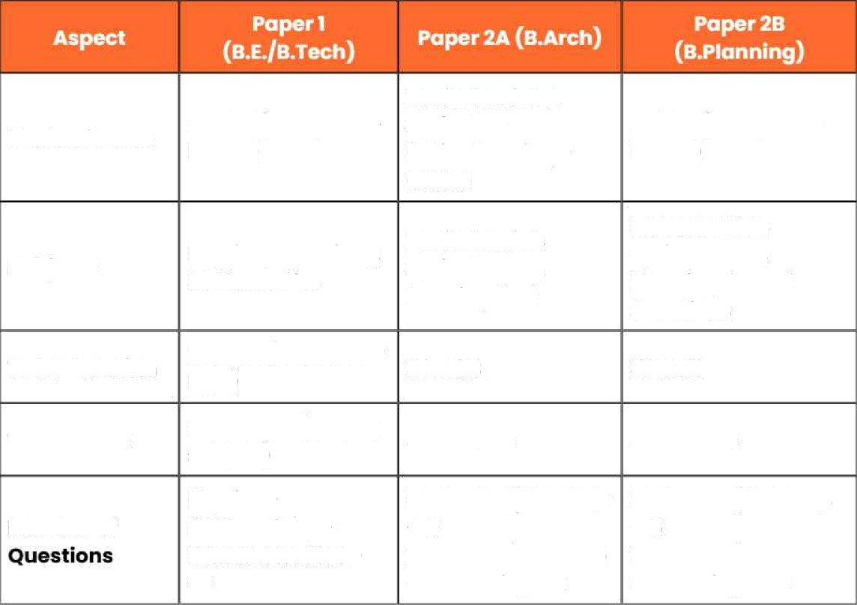
unclerstonding the JEE Main 2026 exam pattern is the first step toward effective preparation. To help aspirants get a clear picture, we've provided a detailed breakdown Df the JEE Mains paper pattern 2026, including the number of questions, marking scheme, and subject—wise structure. Knowing the format in advance helps students plan smarter and perform better on exam day.
Mode of Exam
Online (Computer- Based)
Mathematics 6‹ Aptitude — OnlineDrowing — OffJine
Online (Computer— Based)
Subjects
Physics, Chemists Mathematics
Mathematics,
Aptitude Test,
Drawing Test
Mathematics, Aptitucle Test, Planning-based
Questions
Total Duration
2 hours (4 hours for y
PwD)
›OUFS
3 hDUrS

300 marks (100  Total Marks subect) | per 4 0 works 400 marks
Physics - | Math - 25 (20 MCQs | Moth - 25 (20 MCQs
Number of 25Chemlstry — | + 5 | + 5
25Mothemotics | — NumericoI)Aptitude | NumericoI)Aptitude —
25 | — 50Drowing — 2 | 50Plonning - 25

Numericol Volue Questions | 5 per subject (oll compulsory) | 5 in Moth — oli CDFFlpLllSOry | 5 in Moth - oli compulsDry
Question Types | 20 MCQs + 5  Numericol (per subject) | MCQs (Moth 6‹ Aptitude) + Drowing Tosks | MCQs + Numericol + Plonning-bosed
Morking Scheme | +4 for correct, —1 fDF incorrect | +4 for correct, -1 for  incorrect, 0 for unottempted | +4 for carrect, -1 for  incDrrect, 0 for unottempted
Longuoges Offered | English, Hindi, Assomese, Bengoli, Gujaroti, Konnado, Morathi, Moloyolom, Odio, Punjobi, Tamil, Telugu, Urdu 6‹ more | Some os Paper 1 | Same as Paper 1

JEE Main Exam Pattern for Paper 1 (B.E./B.Tech)
The duration of Paper is 3 hours (4 hours for PwD candidates). The test is conducted online in computer-based mode and includes three subjects - Physics, Chemistry, and Mathematics.

Eoch subject has two sections:
- SRCtÏDFï A: 20 multiple—choice questions (MCQs)
- Section B: 5 numericol value questions
- Ali 75 questions ore compulsory.

JEE Main Paper ï Pottern Overview

  Mode of Examination |  |  |  | Computer- Based Test (Online)
Number of Papers |  |  |  | Two — Paper 1 and Paper 2
Exam Duration |  |  |  | 3 hours (4 hours for PwD candidates)
Subjects |  |  |  | - Physics  - Chemistry  - Mathematics
Questions per Subject |  |  |  | 25 each
Type of Questions |  |  |  | - Section A — MCQs;  - Section B — Numerical values
Total Questions |  |  |  | 75
Total Marks |  |  |  | 000
Marking Scheme |  |  |  | • +4 fOf CDrrect answer  - —1 for incorrect  - 0 for unottempted
Languages |  |  |  | English, Hindi, Assomese, Bengoii, Kannada, Molayalom, Marathi, Odio, Punjabi, Tamil, Telugu, Urdu, Gujoroti

This paper ev'aIuotes both theoretical knowledge and problem-solving ability in core science subjects.

JEE Main Exam Pattern for Paper 2 (B.Arch and B.Planning)

The
Paper 2 exam pattern varies slightly for B.Arch {Paper 2A) and B.Planning (Paper 2B). Bath papers have a 3-hour duration, and each carries 400 marks.

JEE Main Exam Pattern for Paper 2 for B.Arch (Paper 2A)
- Conducted in online + offline mode (the drawing test is pen-and—paper
based).
- Includes Mathematics, Aptitude, and Drawing sections.
- The Drawing section consists of 2 questions (50 marks each).
- All other sections ore compulsory.

JEE Main Exam Pattern for Paper 2 for B.Plan {Paper 2B)
- Conducted entirely online (CBT).
- Includes Mathematics, Aptitude, and Planning sections.
- The Planning section has 25 questions to assess analytical and design skills.

JEE Main Paper 2 Pattern Overview

Duration |  | 3 Hours |  | 3 Hours
Mode of Exam |  | Online + Offline |  | Online
Sections |  | Mathematics, Aptitude, Drawing |  | Mathematics, Aptitude, Planning
Total Questions |  | 77 |  | lOO
Total Marks |  | 400 |  | 400
Type of  @UBStlOWS |  | MCQs, Numerical, Drawing |  | MCQs, Numerical
Marking Scheme |  | +4 fDr Correct, —1 for incorrect, 0 for unottempted; Drawing — 50 marks  2 |  | +4 for CDrrect, -1 for  incorrect, 0 for unottemptecl
Languages |  | English, Hindi, Assamese, Bengali, Kannada, Malayalom, Marathi, Odio, Punjabi, Tamil, Telugu, Urdu, Gujaroti |  | Same as Paper 2A

JEE Main 2026 Exam Pattern: Total Number of Questions
The JEE Main 2026 exam will consist of three separate papers for B.E./B.Tech, B.Arch, and B.Planning courses. Each paper foIIDWS 0 distinct pattern with a different number of questions and sections

Below is the detailed subject-wise breakup of total questions in all three papers.

Total Questions in JEE Main 2026 Paper 1 {B.E./B.Tech)

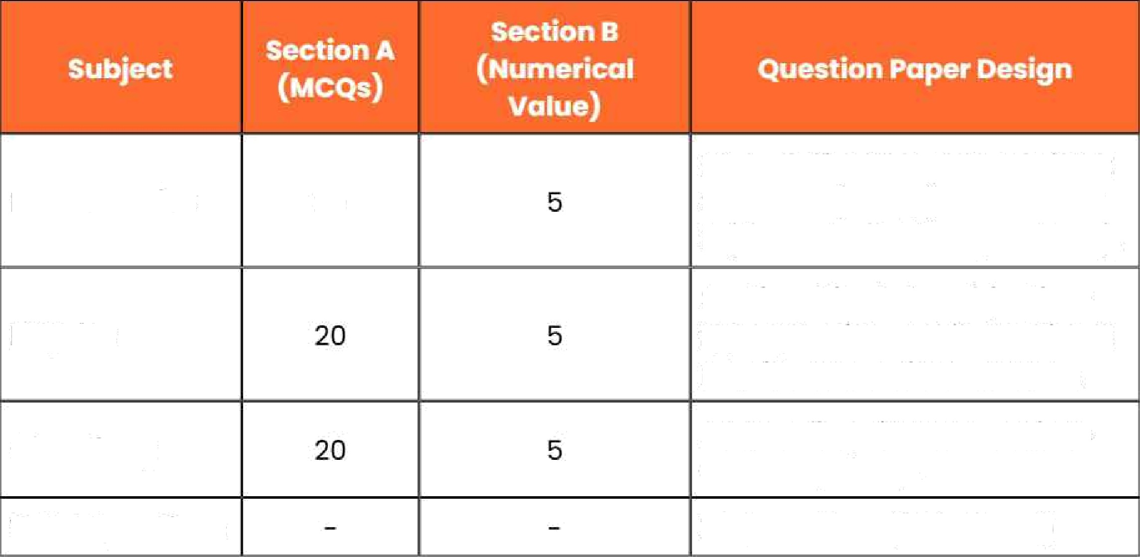
Mathematics
2O
Each subject has two sections:
Section A (MCQs) onci Section B (Numerical Value Questions}.
Physics
Section A includes objective-
type questions, while Section B requires numerical answers.
Chemistry
All questions in both sections
ore compulsory.
Total Questions
75 Questions (300 Marks)

Total Questions in JEE Main 2026 Paper 2A (B.Arch)

Mathematics (Port I) 20

Aptitude Test (Port
ii) 5O
Drawing Test (sort

ii)
Total Questions
Part I has two sections — Section A with MCQs and Section B with numerical questions.
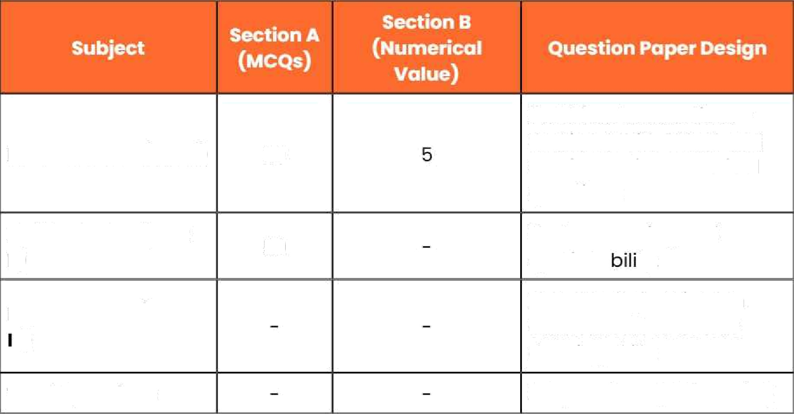

Tests reasoning and

Includes 2 questions in offline mode to assess drawing skills.
77 Questions (400 Marks)

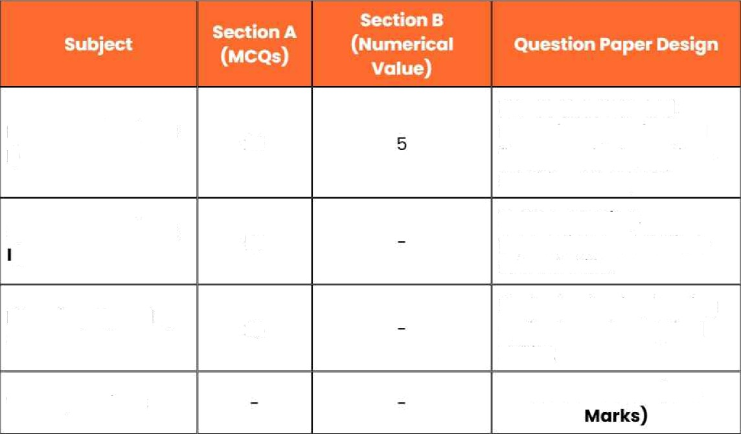
Mathematics (Port i)
20
Aptitude Test (Port
)
50
Planning-Based
Questions (Port III)
25
Total Questions
Part I has MCQs and numerical questions; all five numerical questions must be attempted.
Tests reasoning, perception, and design— related skills.
Evaluates basic planning aptitude and analytical ability.
TOO Questions (400

JEE Main Marking Scheme Summary
- Paper (B.E-IB.Tech): Total 300 marks
+4 marks far each correct answer
—1 mark for each incorrect answer
° 0 marks for unattempted questions
- Paper 2 (B.Arch/B.Planning): Total 800 marks (400 each)
+4 marks for each correct answer
—1 mark for each incorrect answer
° 0 marks for unattempted questions
For Drawing (Paper 2A): 2 questiDns of 50 marks each

Is There Any Change in JEE Main Exam Pattern 2026?

No, there is no change in the JEE Mains 2026 exam pattern. The NTA introduced modifications in 2025, and those updates remain the some this year.

- In Paper 1 (B.E./B.Tech), Section B now has five numerical questions per subject, and all ore compulsory — there are no optional questions.
- Similarly, in Papers 2A (B.Arch) and 2B (B.Planning), the Mathematics section also includes five compulsory numerical questions with no choices.

Important Study Materials Links for JEE Exams


1 | JEE Main Notes
2 | JEE Advanced Notes
3 | JEE Main Important QuestiDn
4 | JEE Advanced Important Question
s | JEE Main Question Paper
6 | JEE Advanced Question Paper
7 | JEE Main Sample Paper
B | JEE Advanced Sample Paper
9 | JEE Main Syllabus
10 | JEE Advanced Syllabus
11 | JEE Main Monk Test Series
12 | JEE Advanced Mock Test Series
13 | JEE Preparation Tips
T4 | JEE Main Formulas
i5 | JEE Advanced Formulas
16 | JEE Main Difference Between
l7 | JEE Advanced Difference Between
18 | JEE Main Topic
1s | JEE Main Question and Answers
20 | JEE Advanced Question and Answers

L+a• L: ''E Oriline

Popular Vedontu Learning Centres Neor You

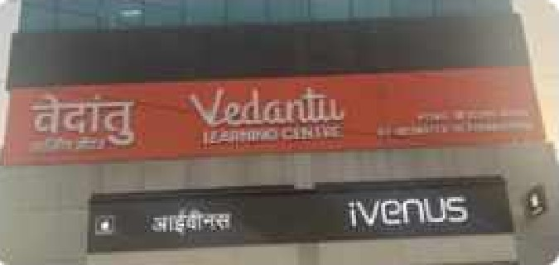



Pimpri Chinchwad, Pune
@ Vedantu Learning Centre, 2nd Floor, Vosont Centre, Above
Aundh, Pune
Vedantu Learning Centre, Sth floor, Vasundhara space,

View More
Sinhagad Road, Pune
@ Vedontu Learning Centre, Office No. 301, FIOOr NO. 3, S.NO.J9,

Courses (class 3








NEET Crash



Olympiod
JEE NEET
JEE/NEET
Foundation
CBSE ICSE

Book your *"r«c’ f3»‹ .o session
Get a flavour of LIVE classes here at Vedontu



Vedontu Improvement Promise
We promise improvement in marks or get your fees
back. T6C Apply*

